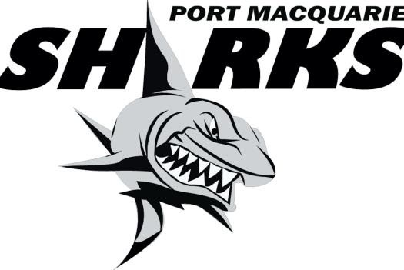

PORT MACQUARIE JUNIOR OZTAG 2023
------------------------------------------------------

REPRESENTATIVE INFORMATION
Thank you for nominationg to be a part of the Port Macquarie
Sharks Junior Oztag Representative Squads.
Good luck!
There a number of expectations in which the Port Macquarie Junior Oztag Association expect of players, parents and officials in the lead up and throughout the tournament in Coffs Harbour.

- Tournament dates for 11 yrs – 17 yrs are Friday 24th Feb – Sunday 26th Feb 2023 at the C-Ex Coffs International Stadium, Stadium Drive, Coffs Harbour and the 9 yrs – 10 yrs are from Saturday 11th to Sunday 12th February 2023 and is held at the The Kingsway Playing Fields, Werrington, Sydney. Parents are to book their own accommodation and organise travel to and from the venue.
- Compulsory training is essential and will commence in October.
- One payment of $225 is will be paid on the OES website.
- The Player Registration fee is $225 per player. This includes tournament fees, uniform (shorts or tights, shirt or singlet and 1 pair of socks) and admin levy. (Active Kids Voucher cannot be used).
- Payment is non-refundable, (although registration fee will be returned) If payment is not received on time, the place may be offered to another player.
- If you have been selected as a “shadow” player, please complete the code of conduct. No payment is due unless the player is drafted into the team.
- Players are to respect the game and be supportive of their team mates, coach and manager at all times.
- Players are to respect that coaches volunteer their time, and are required to attend all training sessions. If unable to attend training, they must notify coach/manager. Players should arrive at training 10 minutes beforehand. Any player that continues to be late, absent or fails to apply satisfactory effort may have their position revoked.
- Up to date information will be posted to the Port Macquarie Oztag Website and Facebook Page.

PORT MACQUARIE JUNIOR OZTAG
---------------------------------------------

CODE OF CONDUCT 2023

- Players and officials are to adhere to all tournament rules at all times.
- Never engage in disrespectful conduct of any sort including profanity, sledging, obscene gestures, offensive remarks, trash talking, taunting or other actions that are demeaning to your team mates, opposition players, officials or supporters.
- Players and officials are to accept the referees’ decision, and never argue.
- Recognise that many officials, coaches and referees are volunteers who give up their time to provide their services. Treat them with the utmost respect.
- Parents and supporters are to behave! Unsportsmanlike language, harassment or aggressive behaviour will not be tolerated.
- Officials are to conduct themselves in a manner at all times and in all situations, that shows leadership, respect for the game and the rules, and respect for those that are involved in the game – players, officials, volunteers and the referees.
- Coaches or Managers are to escalate any issues concerning the tournament to Katrina Davis, who in turn will resolve with the Tournament Director. No official is to directly engage Australian Oztag.
- Please do not comment on any form of social media on anything relative to the tournament, teams, officials or the running there of.
- The production and distribution of any unauthorised apparel is forbidden.
- Any representative player who withdraws from the squad; all replacements must be approved by the Committee.

We are responsible for the conduct of our association. Breaches to the above conduct will result in penalties, including but not limited to:

- Suspension of a player, parent or official from the upcoming Port Macquarie Junior Oztag
Summer Competition.
- Suspension of a player, parent or official for the following Junior Nationals (2023) and following years Junior State Cup (2024)
- These penalties are in addition to any penalty which may be imposed by NSW Oztag or Australian Oztag.

**By nominating on the google form you are agreeing to abide by these reles and regulations.

